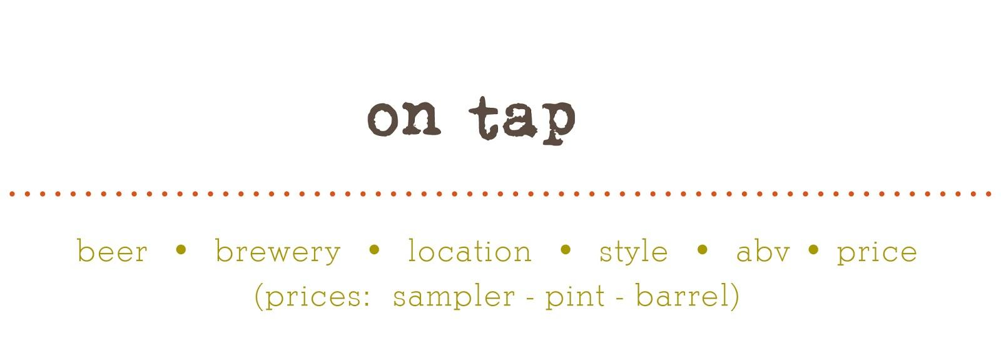

NEW & SEASONALS
ol’factory pils • two roads brewing • CT • german pilsner • 5% • 2.5 – 7.5 – 30
the crisp • sixpoint brewery • NY • german pilsner • 5.4% • 1.5 – 6.5 – 24
red seal ale • north coast brewing co. • CA • red ale • 5.5% • 1.5 – 5.5 – 23
great ketch • grey sail • RI • amer. DBL/imperial pilsner • 8.5% • 3 – 8…***
tank 7 • boulevard brewing co. • MO • saison • 8.5% • 2 – 7.5…..***
golden monkey • victory • PA • tripel • 9.5% • 2.5 – 7.5…***

PALE ALES & IPAS
all day IPA • founder’s brewing co. • MI • american IPA • 4.7% • 2 – 6 – 25
camp wannamango • harpoon • MA • american pale ale • 5% • 2 – 6 – 25
queen of the yahd • foolproof • RI • american DBL/imperial IPA • 6% • 2.5 – 7 – 30
red’s rye IPA • founder’s brewing co. • MI • rye ale • 6.0% • 2.5 – 8.5 – 40
hop nosh • uinta brewing • UT • american IPA • 7.3% • 2.5 – 7…***
stingray IPA • coronado brewing co. • CA • american DBL/imperial IPA • 7.9% • 3 – 8……***
double black IPA • revival brewing co.. • RI • american black ale • 8.0% • 2 – 6.5……***
the calling • boulevard brewing co. • MO • imperial IPA • 8.5% • 2 – 7.5……***
90 minute IPA • dogfish head • DE • american DBL/imperial IPA • 9% • 2.5 – 8.5…***

WHEAT & FRUIT BEERS
ginger-lemon radler • boulevard • MO • fruit/veggie • 4.1% • 2.5 – 8 – 34
summer shandy • leininkugel • WI • fruit/veggie • 4.2% • 2 – 6 - 23
UFO Big Squeeze • harpoon • MA • fruit/veggie• 4.5% • 2 – 6 - 23
hell or high watermelon • 21st amendment • CA • fruit/veggie • 4.9% • 2 – 6 – 23
road jam • two roads brewing • CT • american pale wheat ale • 5% • 2.5 – 7 - 30
no limits • two roads brewing co. • CT • hefeweizen • 5.0% • 2 – 6 – 26
allagash white • allagash brewing co. • ME • witbier • 5.0% • 2 – 6.5 – 26
white ale (nitro) • samuel adams • MA • witbier • 5.2% • 2.5 – 7.50 – 30

LAGERS
boston lager • sam adams • MA • vienna lager • 4.9% • 2.5 – 7.5 – 28
brooklyn lager • brooklyn brewing co. • NY • vienna lager • 5.2% • 1.5 – 6 – 25
house lager • jacks abby • MA • munich helles lager • 5.2% • 1.5 – 6.5 – 24
dead guy ale • rogue brewing co. • OR • maibock/hellesbock • 6.5% • 2 – 7.5 – 30
hoponius union • jacks abby • MA • american pale lager • 6.7% • 2 – 6.5 – 26

*** specialty and high abv brews are served in a 12oz tulip glass, and are not available by the barrel

BROWN, AMBER & STRONG ALES
granola brown• black hog brewing • CT • american brown ale • 5.5%% • 1.5 – 6 – 25
kentucky bourbon ale • alltech • KY • english strong ale • 8.19% • 2.5 – 8…***
gnomegang • ommegang • NY • belgian strong pale ale • 9.5% • 3.5 – 9…***

PORTERS & STOUTS
boston irish stout (nitro) • harpoon • MA • irish dry stout • 4.3% • 2.5 – 7.50 - 32
master of disguise • stone • CA • Amer DBL/Imp Stout • 9.7% • 2.5 – 8.5…***

MONASTIC/FARMHOUSE/WILD ALE
tell-tale tart • boulevard • MO • amer. wild ale • 6.2% • 3.5 – 9 – 36

GLUTEN-FREE
cranberry blend • downeast cider house • ME• hard cider • 5.0% • 1.5 - 5.5 – 26
stone dry • angry orchard • OH • cider • 5.5% • 2.5 – 7.5 – 30

NON-ALCOHOLIC
captain eli’s • root beer • ME • 1.00 - 2.50 - n/a

CASK
please ask your server or bartender for the cask of the week • *** (avail. wed. - sat.)

*** specialty and high abv brews are served in a 12oz tulip glass, and are not available by the barrel

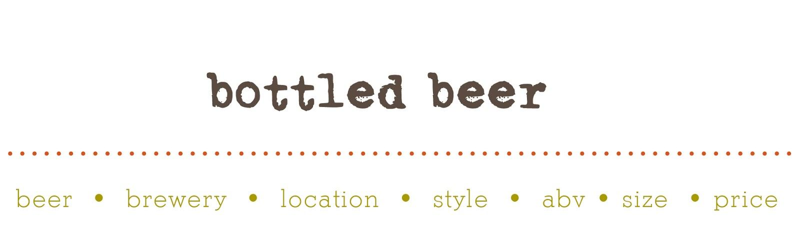

PALE ALES & IPAS daytime • lagunitas brewing • CA • american IPA • 4.65% • 12oz • 5
lil’ heaven • two roads brewing co. • CT • american IPA • 4.8% • 12oz can • 5
dale’s pale ale •oskar blues grill & brew • CO • american pale ale • 6.5% • 12oz can • 5.5
sculpin • ballest point brewing co. • CA • american IPA • 7.0% • 12oz can • 7
torpedo extra IPA • sierra nevada brewing co. • CA • american IPA • 7.2% • 12oz • 5
sucks • lagunitas brewing co. • CA • imperial IPA • 7.85% • 32oz • 17 ruination 2.0 • stone brewing co. • CA • imperial IPA • 8.5% • 12 • 7.5
local 1 • brooklyn brewery • NY • belgian strong pale ale • 9.0% • 750ml • 22
resin • sixpoint brewing co. • NY • imperial IPA • 9.1% • 12oz can • 6.5
decadence • alesmith brewing company • CA • belgian strong pale • 10.0% • 750ml • 30

WHEAT & FRUIT BEERS
blueberry • wachusett brewing co. • MA • fruit/veggie ale • 4.5% • 12oz • 5
magic hat #9 • magic hat brewing company • VT • fruit beer • 5.1% • 12oz • 4.5 berliner weisse • white birch brewery • NH • berliner weissbier • 5.5% • 12oz can • 5
blueberry berliner weisse • white birch brewery • NH • berliner weissbier • 5.5% • 12oz can • 5
grey lady • cisco brewers inc. • MA • witbier • 4.5% • 12oz can • 5
double white • southampton publick house • NY • witbier • 6.7% • 12oz • 5 little sumpin’ sumpin’ • lagunitas brewing • CA • am. pale wheat ale • 7.5% • 12oz • 5.5
apricot ale • cascade brewing. • OR • american wild ale • 8.5% • 750ml • 45

BROWN, AMBER & STRONG ALES american amber ale • rogue ales • OR • american amber/red ale • 5.3% • 12oz • 6.5
old brown dog • smuttynose brewing co. • NH • american brown ale • 6.7% • 12oz • 5
sawtooth nitro ale • left hand brewing co. • CO • extra special bitter • 7.5% • 12oz • 6
curmudgeon • founders brewing co. • MI • old ale • 9.8% • 12oz • 8

PORTERS & STOUTS
moo thunder stout • butternuts beer & ale • NY • milk/sweet stout • 4.8% • 12oz can • 5
vanilla java porter •atwater brewery • MI • american porter • 6.0% • 12oz • 6.5
black jack • left hand brewing co. • CO • english porter • 6.8% • 12oz • 5.5
americano stout • stone brewing co. • CA • american double/imperial stout • 8.7% • 12oz • 8
black betty • nebraska brewing company • NE • imperial stout• 11.3% • 750ml • 35
speedway stout • alesmith • CA • American DBL/Imperial • 12% • 25.4oz • 25

LAGERS
baba black lager • uinta brewing co. • UT • schwarzbier • 4.0% • 12oz • 4
narragansett lager • narragansett brewing • RI • american adjunct lager • 5% • 16oz • 3
pacifico • grupo modelo s.a.de c.v. • mexico • american adjunct lager • 4.5% • 12oz • 4.5 session lager • full sail brewery • OR • american pale lager • 5.1% • 11oz • 4

FARMHOUSE/MONASTIC & SOUR rosetta • brewery ommegang • NY • lambic – fruit • 5.6% • 11.2oz • 8 grand cru • brouwerij rodenbach N.V. • Belgium • flanders red • 6.0% • 12oz • 10
spencer trappist ale • spencer brewery • MA • belgian pale ale • 6.5% • 11.2oz • 10 sophie • goose island beer co. • IL • saison/farmhouse • 6.5% • 12oz • 8
belle fermiere • overshores brewing company • CT • saison • 6.6% • 12oz • 7.5
oude tart • the bruery • CA • flanders red ale • 7.5% • 750ml • 40
gypsy tart • the bruery • CA • flanders red ale • 8.4% • 750ml • 40

GLUTEN-FREE
omission lager • widmer bro. brewing • OR • light lager • 4.6% • 12oz • 5
omission pale ale • widmer bro. brewing • OR • american pale ale • 5.8% • 12oz • 5
tweason’ale • dogfish head brewery • DE • fruit/veggie • 6.0% • 12oz • 7
the hatchet (original) • sonoma cider • CA • hard cider • 6.0% • 12oz • 7
the pitchfork (pear) • sonoma cider • CA • hard cider • 6.0% • 12oz • 7
the anvil (bourbon) • sonoma cider • CA • hard cider • 6.1% • 12oz • 7

NON-ALCOHOLIC
clausthaler • binding-brauerei AG • germany • non-alcoholic • 12oz • 3.5

DAVE’s COFFEE
dark roast •medium roast • decafe • specialty bean (ask for details) • 16oz • 3.5

