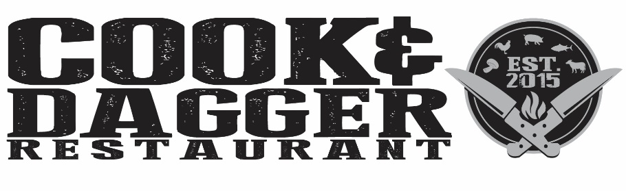

Brunch Cocktails

All Served in a Personal 24 oz. Jar $10

Mimosa

“Man”mosa (add $2)

Bloody Mary

Blush Sangria

\*Consuming raw or undercooked meats, poultry, shellfish, or eggs may increase your risk foodborne illness

Please inform your server of any food allergies

Brunch Plates

New England Clam Chowda $7

Cream, Potato, Dill, and Bacon

Gumbo $7

Andouille Sausage, Chicken, Holy Trinity

Croquettes $7

Manchego Cheese, Serrano Ham, Chipotle Aioli

O.G. Benny \* with Home Fries $10

Benny Du Jour\* with Home Fries $10

French Toast Bananas Foster-Glocester $11

Chicken Fried Steak & Eggs\* $15

Roasted Poblano Gravy, Home Fries, Biscuit

Breakfast in a Jar\* $13

Braised Short Rib, Bacon, Yukon Gold Potato Hash, Truffle, Poached Egg

Build Your Own Omelet $9

Choice of Peppers, Onions, Mushrooms, Broccoli, Bacon, Sausage, Arugula, Cheddar, Swiss, Manchego, or American Cheese with Home Fries

Breakfast Burger $15

2 - 5oz. Patties, Sunny Side Egg, Cheddar, Bacon, Maple Aioli, English Muffin with Fries

Breakfast Tacos $10

Sausage, Peppers, Onion, Cheddar Served with Black Beans

Pork Belly Quesadilla $11

Queso Blanco, Charred Pineapple, Poblano, Leeks, Confit Radish

Smoked Salmon Tartine $11

Egg, Tomato, Onion, Olives, Capers, Toasted Baguette, Side Salad with Sherry Vinaigrette

Monte Cristo $12

Ham, Swiss, Strawberry Jammy Jam on Country White with Fries

Shrimp and Grits $20

Shrimp, Andouille Sausage, Shishito and Fresno Peppers, Onions, White Wine Butter

Chicken & Dumplings $18

Pan Seared Statler, Baby Carrots, Celery, Cream, Dumplings

Chef Salad $12

Mixed Greens, Ham, Chicken, Hard Boiled Egg, Fingerling Potatoes, Tomato, Onion, Buttermilk Dill

Caesar Salad $10

Grilled Hearts of Romaine, House Made Creamy Caesar Dressing, Parmesan, Crostini Add: Shrimp $8, Chicken $5

Cheeseburger\* & Fries $13

American & Cheddar Cheeses, Lettuce, Tomato Add: Bacon, Egg, Caramelized Onions, Mushrooms, or Truffle Aioli for $1 each

Grilled Cheese & Tomato Bisque $13

Sharp Cheddar, Bacon Jam, Sliced Apple Served with a Bowl of Tomato Bisque